# Problem 1

* Franchise (Retail Database: Franchise)
  + FranchId
  + FranchRegion
  + FranchPostalCode
  + FranchModelType
* Date (Retail Database: SalesDate, ServPurchDate, MmbDate & Spreadsheet: EventDate)
  + Year
  + Month
  + Day

Hierarchical (year → month → day)

* ProductSold (Retail Database: Mechandise, ServiceCategory & Spreadsheet)
  + MerchId & ServId
  + MerchName & SerCatName & EventName
  + MerchType & EventTypeCode

ProductSold includes Merchandise, Service, Event

* Customer (Retail Database: Member & Spreadsheet)
  + MmbId & CorpCustId
  + MmbName & CorpCustName
  + CorpCustLoc
  + MmbEmail
  + MmbZip
  + MemTypeId

Customer includes Member & Corporate Customer

# Problem 2

* Qty (Contains Table): additive measure
* MerchPrice (Merchandise Table): non additive measure
* ServCatPrice (ServiceCategory Table): non additive measure
* SpecialEventAmount(Spreadsheet): non additive measure

# Problem 3

1. Dimensions
   * Franchise: 350
   * Products: 500 (Mechendise) + 20(ServCategory) + 1(Special Event) = 521
   * Customer: 50000 + (150(Customer) * 200(Franchise)) = 80000
2. Fact Table Size
   * 450000(Contains) + 100000(ServicePurchase) + 300 * 200 (SpecialEvents) = 610000
3. Sparsity
   * 1 – (Fact Table Size/ Product of Dimensions)
   * 1 – (610000/(365 * 350 * 521 * 80000)) = 0.99999988543783406139780866991447

# Problem 4

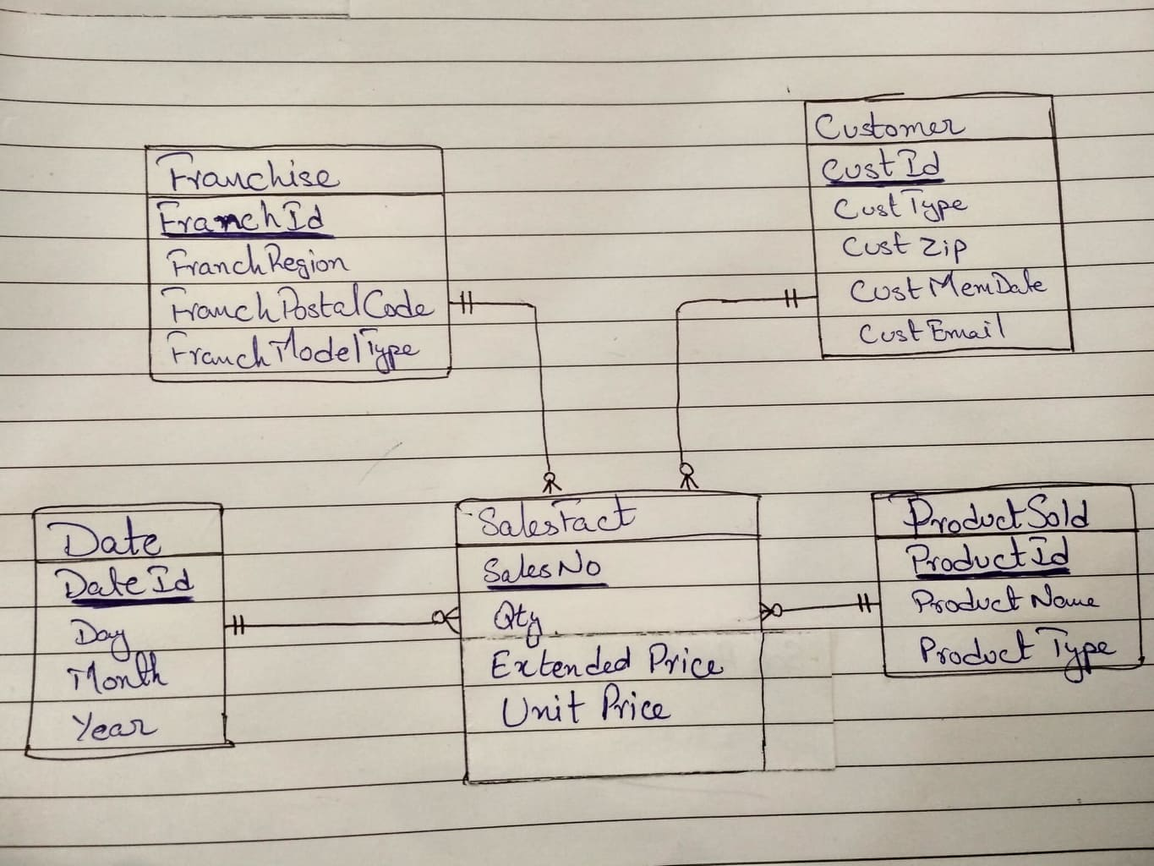

# Problem 5

* CustType (MemberType) is missing some types like guest
* Incomplete dimension fact relationship for Franchise
* CustMemDate(MemberDate) will be null as non-corporate customers only have CustType(MemberType)
* Zip code is not available for all Customers
* Guest members and Corporate customers don’t have memberships hence no MembershipDate aswell

# Problem 6

Giving ProductId to Special Events

All identifiers converted into one format

|  |  |  |
| --- | --- | --- |
| ***ProductSold*** | | |
| *ProductId* | *ProductName* | *ProductType* |
| 1111 | Wilson balls | MRCH |
| 1112 | Wilson racket | MRCH |
| 1113 | Adidas shoes | MRCH |
| 1114 | Racket stringing | MRCH |
| 1115 | Ball machine | PASS |
| 1116 | Private lesson | PASS |
| 1117 | Adult class | PASS |
| 1118 | Child class | PASS |
| 1119 | Adult social | EVNT |
| 1120 | Pioneer social | EVNT |
| 1121 | Team practice | EVNT |
| 1122 | Platinum membership | MMBR |
| 1123 | Gold membership | MMBR |
| 1124 | Value membership | MMBR |

|  |  |  |  |
| --- | --- | --- | --- |
| **Franchise** | | | |
| *FranchId* | *FranchRegion* | *FranchPostalCode* | *FranchModelType* |
| 1111 | Northwest | 98011 | Full |
| 1112 | Mountain | 80111 | Medium |
| 1113 | Central | 45236 | Limited |

|  |  |  |  |
| --- | --- | --- | --- |
| ***Date*** | | | |
| *DateId* | *Day* | *Month* | *Year* |
| 1111 | 10 | 2 | 2013 |
| 1112 | 11 | 2 | 2013 |
| 1113 | 12 | 2 | 2013 |
| 1114 | 13 | 2 | 2013 |
| 1115 | 14 | 2 | 2013 |
| 1116 | 15 | 2 | 2013 |
| 1117 | 16 | 2 | 2013 |
| 1118 | 17 | 2 | 2013 |
| 1119 | 18 | 2 | 2013 |
| 1120 | 19 | 2 | 2013 |
| 1121 | 20 | 2 | 2013 |
| 1122 | 21 | 2 | 2013 |

New CustType are created M4 for guest and M5 for Corporate Customer

CustId was given to Corporate customers

All CustId were made into one format

|  |  |  |  |  |  |
| --- | --- | --- | --- | --- | --- |
| **Customer** | | | | | |
| *CustId* | *CustName* | *CustZip* | *CustType* | *CustMemDate* | *CustEmail* |
| 1111 | Joe | 80111 | M1 | 1-Feb-2009 | joe@serv1.com |
| 2222 | Mary | 80113 | M2 | 1-Jan-2010 | mary@serv2.com |
| 3333 | Sue | 80114 | M3 | 3-Mar-2011 | sue@serv3.com |
| 4444 | George | 80112 | M4 |  | george@serv4.com |
| 5555 | Frist Data |  | M5 |  |  |
| 6666 | DU Tennis |  | M5 |  |  |
| 7777 | Creek |  | M5 |  |  |

Retail Database & Spreadsheet

|  |  |  |  |  |  |  |  |
| --- | --- | --- | --- | --- | --- | --- | --- |
| ***SalesFact*** | | | | | | | |
| *SalesNo* | *CustId* | *DateId* | *ProductId* | *FranchId* | *Qty* | *ExtendedPrice* | *UnitPrice* |
| 1 | 1111 | 1111 | 1111 | 1111 | 2 | $30 | $15 |
| 2 | 1111 | 1111 | 1112 | 1111 | 1 | $200 | $200 |
| 3 | 2222 | 1113 | 1114 | 1112 | 1 | $40 | $40 |
| 4 | 3333 | 1113 | 1113 | 1113 | 1 | $100 | $100 |
| 5 | 4444 | 1114 | 1114 | 1113 | 1 | $40 | $40 |
| 6 | 1111 | 1114 | 1114 | 1111 | 1 | $15 | $15 |
| 7 | 2222 | 1115 | 1116 | 1112 | 1 | $75 | $75 |
| 8 | 4444 | 1116 | 1117 | 1113 | 1 | $150 | $150 |
| 9 | 5555 | 1114 | 1119 | 1111 | 1 | $1,000 | $1,000 |
| 10 | 6666 | 1115 | 1120 | 1111 | 1 | $500 | $500 |
| 11 | 7777 | 1122 | 1121 | 1112 | 1 | $200 | $200 |
| 12 | 8888 | 1111 | 1122 | 1112 | 1 | $1,000 | $1,000 |
| 13 | 9999 | 1116 | 1123 | 1113 | 1 | $800 | $800 |
| 14 | 9998 | 1122 | 1124 | 1113 | 1 | $300 | $300 |